Sampling

Sampling is a technique used to select a smaller portion (sample s) from a large dataset N to represent the entire dataset.
The main goal of sampling is to make data analysis faster and more manageable without needing to process the entire dataset.
Why Sampling is Useful
- Efficiency:
When you have a very large dataset, running algorithms on the entire dataset can be slow and computationally expensive. By working with a smaller, representative sample, you can significantly reduce the time and resources needed for analysis.
- Complexity:
Sampling allows some algorithms to run more efficiently, with complexity that is potentially sub-linear to the size of the data, meaning the time it takes to run doesn’t increase as quickly as the size of the data does.
Key Principle: Choose a Representative Subset
- Representative Sample:
The sample you choose should accurately reflect the characteristics of the whole dataset. If the sample is not representative, the analysis results might be misleading.
- Simple Random Sampling:
This is the most basic method, where each data point has an equal chance of being selected. However, it can lead to poor results if the data is skewed, meaning certain patterns or groups are overrepresented or underrepresented in the sample.
Dealing with Skewed Data: Adaptive Sampling
- Stratified Sampling:
When the data is skewed or contains distinct subgroups, adaptive methods like stratified sampling are used. In stratified sampling, the data is divided into different groups (strata) based on certain characteristics, and then a sample is taken from each group. This ensures that all parts of the dataset are fairly represented in the sample.
  - Example:
If you are sampling from a dataset of students that includes different majors, you would ensure that students from each major are represented in your sample, rather than just randomly selecting students which might overrepresent one major.
How should we choose samples
- Probability sampling technique
Each member of the population has a chance of being selected. It is mainly in quantitative research.

- Non-Probability sampling
Not all the members of the population have equal chance of participating in the study.

Probability sampling includes:
- Simple random sampling
- Systematic sampling
- Stratified sampling
- Proportional sampling
- Cluster sampling

- Simple random sampling
In simple random sampling, every data point in the dataset has an equal chance of being selected. This method is straightforward and easy to implement. Equivalently, all samples of size n have an equal chance of being selected. Random samples are obtained either by sampling with replacement from a finite population or by sampling without replacement from an infinite population.

Sampling without replacement
Once object is selected then it is removed from the population

Sampling with replacement
Once object is selected then it is not removed from the population

Suppose you have a small dataset consisting of the following 10 students, each represented by their student ID:
- Student IDs: 1, 2, 3, 4, 5, 6, 7, 8, 9, 10
You want to select a sample of 4 students from this group using simple random sampling.
Step-by-Step Process:
1. Assign an Equal Probability to Each Student:
Since there are 10 students, each student has an equal chance of being selected. The probability of selecting any one student is 110=0.1\frac{1}{10} = 0.1101​=0.1 or 10%.

2. Randomly Select 4 Students:
You can use random methods such as drawing lots, using a random number generator, or even rolling a 10-sided die to choose 4 student IDs.
Let’s say you use a random number generator and the following IDs are selected:
- Selected IDs: 3, 7, 1, 10
3. Sampling Without Replacement:
In this case, since we are sampling without replacement, once a student ID is selected, it is removed from the pool. The final selected IDs are:
- Sampled IDs: 3, 7, 1, 10
These 4 IDs represent the sample chosen from the original 10 students.
4. Sampling With Replacement (Alternate Scenario):
If you were sampling with replacement, each time a student ID is selected, it would be returned to the pool, meaning it could be selected again. For example, if you used the random number generator and got:
- Selected IDs: 3, 7, 3, 10
In this case, student ID 3 was selected twice because it was returned to the pool after the first selection. So your sample might contain duplicate IDs.

- Systematic sampling
Systematic sampling is a method of sampling where you select items from a larger population at regular intervals. It's a straightforward and efficient way to create a sample when the data is ordered in some way.

every kth item of the sampling frame is selected, starting from the first element which is randomly selected from the first k elements

How Systematic Sampling Works:
- Start with an Ordered List:
Imagine you have a list of items, like a list of 100 students in alphabetical order.
- Decide the Sample Size:
Let’s say you want to create a sample of 10 students from this list.
- Calculate the Sampling Interval:
The sampling interval is the number of steps you take between each selected item. You calculate it by dividing the total population size by the desired sample size:

Sampling interval= $\frac{Total Population}{Sample size}$
In our example:
Sampling Interval =$\frac{100}{10}$ = 10
So, you’ll pick every 10th student.
- Choose a Random Starting Point:
Pick a random number to start with that’s within your sampling interval. For example, if you choose 3 as your starting point, you’ll start with the 3rd student.
- Select Every 10th Student:
From your starting point (student 3), you then pick every 10th student on the list. So, you would select students at positions 3, 13, 23, 33, and so on.

Stratified sampling
Population is divided into mutually exclusive groups and random samples are drawn from each group. Divide the population into sub groups (called strata) and based on relevant characteristics (eg: gender, age range, income bracket, job role etc)

Mutually exclusive means If one particular element is present in one group then it cannot be part of other group

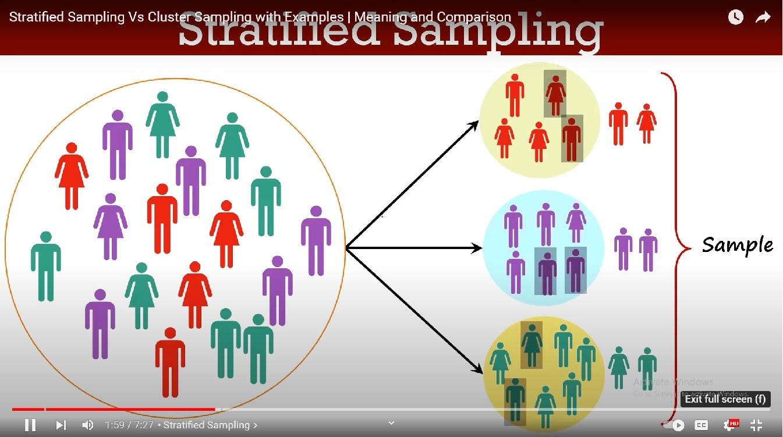

Proportional sampling
Proportional sampling, also known as quota sampling, is a method used to create a sample that accurately reflects the various subgroups within a larger population. Here's how it works in simpler terms:
- Divide the Population: First, the entire population is divided into different groups, called strata. Each stratum represents a specific characteristic, like age, gender, or income level.
- Proportional Selection: Once the groups are formed, a sample is taken from each group. The number of items or individuals selected from each group is proportional to the group's size in the overall population. For example, if one group makes up 20% of the population, 20% of the sample will come from that group.
- Random Selection: Within each group, the individuals or items are chosen randomly. This helps ensure that the sample is unbiased and representative of each subgroup.
Eg is given slides

Cluster sampling
Cluster sampling is a method used to create a sample from a larger population by grouping the population into clusters, then randomly selecting some of these clusters for study. Here's how it works in simple terms:
- Group the Population into Clusters: The entire population is divided into smaller groups called clusters. Each cluster is like a mini-version of the whole population, with a mix of different characteristics, like neighbourhoods in a city or schools in a district.
- While forming a cluster keep in mind that each population cluster is highly diversed so that all the characteristics of the population can be represented.
- Each cluster should have similar distribution of characteristics as a distribution of population.
- Further there should not be any overlapping between the cluster(i.e. mutually exclusive elements)
- When taken together cluster should cover the whole population

- Randomly Select Clusters: Instead of picking individuals from every group, only a few clusters are randomly chosen for the sample.
- Choose the Sample from Clusters: Once the clusters are selected, you either include all the individuals or items from those clusters in your sample, or you randomly select a certain number of individuals from each chosen cluster.

Key Difference from Stratified Sampling:
- Stratified Sampling: Every group (stratum) is represented in the final sample.
- Cluster Sampling: Only a few selected clusters are represented in the final sample, not all groups.
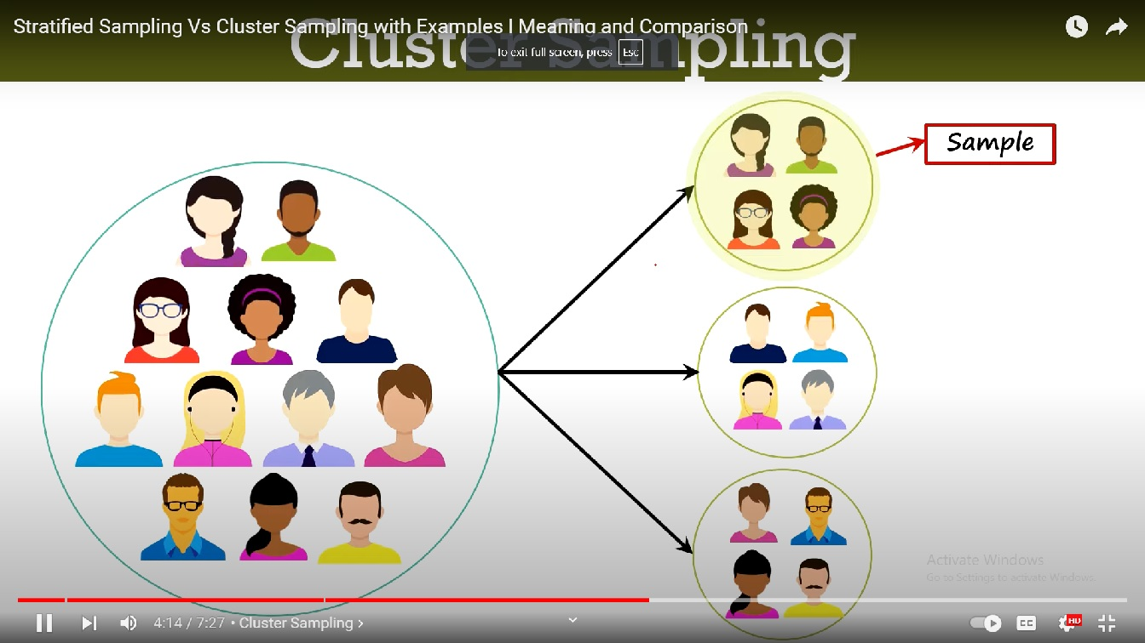

Probability and statistics
Probability:
- Definition: Probability is the science of predicting what might happen when we take samples from a known population. It deals with the likelihood or chance of an event occurring.
- Example: Imagine you have a jar with 100 marbles, 70 of which are red and 30 are blue. If you randomly pick one marble, the probability of it being red is 70 out of 100, or 70%. This tells you the chance that you will pick a red marble if you try.
Statistics:
- Definition: Statistics is the science of collecting, organizing, and analyzing sample data to make conclusions or inferences about a larger, unknown population. It helps us understand and make decisions based on the data we collect.
- Example: Suppose you don't know the actual proportion of red and blue marbles in the jar. You take a random sample of 10 marbles and find that 7 are red and 3 are blue. Based on this sample, you might infer that about 70% of all the marbles in the jar are red. This inference is a statistical conclusion about the unknown population (all marbles in the jar).
How Probability Supports Statistics:
- Connection: Probability helps us understand how likely it is that our statistical conclusions are accurate. It provides a way to measure the reliability of our inferences from a sample to the entire population.
- Example: If you repeatedly take samples of 10 marbles from the jar, you might find that the results vary a little each time. Probability allows you to calculate how likely it is that your sample (e.g., 7 red marbles out of 10) reflects the true proportion of red marbles in the jar. It helps justify the accuracy of your conclusion.

Comparison of probability and statistics
Probability
- Assumes Known Population Properties: Probability works under the assumption that the properties or characteristics of the population (like the proportion of a certain trait) are already known. For example, you might know that 60% of all marbles in a jar are red.
- Answers Questions About Samples: Probability is used to predict or calculate the likelihood of certain outcomes when taking a sample from this known population. For example, if you randomly pick 10 marbles from the jar, probability can tell you the chance that exactly 6 of them will be red.
Statistics
- Uses Sample Information: In contrast, statistics does not assume the population properties are known. Instead, it uses the data from a sample to draw conclusions or make estimates about the unknown population. For example, you take a sample of 10 marbles, observe that 6 are red, and use this information to estimate that about 60% of all marbles in the jar are red.
- Draws Conclusions About the Population: Statistics takes the sample data and attempts to infer the characteristics of the entire population from which the sample was drawn. For example, based on your sample, you might conclude that the population of marbles in the jar is approximately 60% red.
Summary:
- Probability: Starts with known population properties and predicts outcomes in samples.
- Statistics: Starts with sample data and makes inferences about the unknown population properties.

Generalizing from Sample to Population:
- Explanation: When we collect data from a sample, we often use that data to make generalizations about the entire population. For instance, if you survey 100 people about their favourite color, you might use those results to infer what the favourite color of the entire population might be. This process of using sample data to estimate population properties is central to statistics.
Sampling Errors
- Explanation: While sampling is a powerful tool, it's not perfect. Errors can occur, and these errors can impact how accurately we can generalize from the sample to the population. Two common types of errors in sampling are Selection Bias and Sampling Error.
1. Selection Bias:
- Definition: Selection bias occurs when the method used to select the sample is flawed, causing the sample to not accurately represent the population. This happens when certain groups within the population are overrepresented or underrepresented.
- Example: If you're conducting a survey on ice cream preferences and you only sample people outside an ice cream shop, your sample may be biased toward people who already like ice cream, and it won’t accurately reflect the entire population's preferences.
2. Sampling Error:
- Definition: Sampling error is the error that arises purely due to the randomness of the sampling process. Even with a well-chosen, random sample, the sample might not perfectly reflect the population due to chance.
- Example: Suppose you randomly select 100 people from a population to find out how many prefer chocolate over vanilla ice cream. Even if 50% of the population prefers chocolate, in your sample of 100 people, you might find 55% or 45% prefer chocolate simply due to the randomness of who was selected.

Statistical re sampling
Resampling is a statistical technique used to estimate the population parameter (such as the mean or proportion) by repeatedly sampling from the data you already have. This helps in understanding the variability or uncertainty in your estimate.
1. Problem: Single Estimate of the Population Parameter
- Explanation: When you collect a sample from a population and calculate a parameter (like the average or mean), you only get one estimate. This single estimate doesn't give you much information about how much it might vary if you took a different sample. You also don't know how close your estimate is to the true population value.
- Example: Imagine you're trying to estimate the average test score of all students in a school. You randomly select 30 students and find that their average score is 75. This is your estimate of the population's average score, but it’s just one estimate. If you selected a different group of 30 students, the average score might be slightly different—say, 72 or 78. You’re left wondering how reliable your single estimate of 75 is and how much it might vary.
2. Solution: Estimate the Population Parameter Multiple Times (Resampling)
- Explanation: To address the uncertainty of having just one estimate, you can use a technique called resampling. Resampling involves repeatedly taking samples from your original data (often by a method called bootstrapping) and calculating the parameter (like the average) each time. This helps you see how much the estimate can vary and gives you a better sense of the uncertainty.
- Example: Let's go back to the test scores. You have your original sample of 30 students with an average score of 75. Instead of relying on this single estimate, you can use resampling. You randomly select 30 scores from your original sample, but with replacement (meaning a score can be chosen more than once). You calculate the average score for this new sample. You repeat this process many times—say 1,000 times. Now, instead of just one estimate, you have 1,000 estimates of the average score.
How Resampling Helps:
- Understanding Variability: After resampling, you might find that the average scores in your 1,000 samples range from 72 to 78. This range shows you the variability in your estimate and helps you understand that the true average score for all students in the school is likely somewhere within this range.
- Building Confidence: By looking at the distribution of these 1,000 estimates, you can create a confidence interval. For example, you might say that you’re 95% confident that the true average score of all students falls between 73 and 77. This gives you a more informed and reliable understanding of the population parameter than relying on the single estimate of 75.
Summary:
- Problem: A single estimate from a sample doesn’t tell you much about the variability or uncertainty in that estimate.
- Solution: By using resampling, you can generate multiple estimates from your original data, which helps you understand the range of possible outcomes and provides a better sense of how reliable your estimate is. This approach allows you to make more informed conclusions about the population as a whole.
Advantages of Resampling Methods:
- Easy to Use:
  - Explanation: Resampling methods are straightforward to apply. You don't need to worry about complicated formulas or complex statistical theories.
  - Example: Suppose you want to estimate the average weight of apples in a large orchard. Instead of diving into complex statistics, you can simply take a sample of apples, resample it multiple times using a computer, and calculate the average weight each time. The process is intuitive and doesn't require deep mathematical understanding.
- Requires Little Mathematical Knowledge:
  - Explanation: You don’t need to be an expert in math to use resampling methods. The focus is more on repeating simple steps, like taking multiple samples, rather than performing difficult calculations.
  - Example: If you're a beginner learning statistics, you can still use resampling techniques like bootstrapping. You just need to know how to repeatedly sample your data and calculate averages or other statistics. The computer handles the heavy lifting for you.
- Easy to Understand and Implement:
  - Explanation: Resampling methods are not only easy to use but also easy to explain and understand. You can see how the process works and grasp the concept without needing to understand advanced statistical models.
  - Example: If you're teaching someone how to estimate the average height in a group, you can show them how to take a sample, resample it multiple times, and explain how this helps to understand the variability of their estimate. They’ll see the logic behind it, making the concept more accessible.
Disadvantage of Resampling Methods:
- Computationally Expensive:
  - Explanation: The downside of resampling is that it requires a lot of computing power. Since you need to create many resamples (sometimes hundreds or thousands), it can take a long time for a computer to process all the data and give you a robust estimate of the population parameter.
  - Example: Imagine you're using resampling to estimate the average income in a large city. To get a reliable estimate, you might need to create 10,000 resamples. If your computer is not very fast, this could take hours or even days to complete. This is the main challenge with resampling—it’s simple to do, but can be slow and resource-intensive.
Summary:
- Advantages: Resampling is easy to use, doesn’t require deep mathematical knowledge, and is easy to understand and implement. It’s a practical tool for making estimates when you want to avoid complex statistical methods.
- Disadvantage: The main drawback is that it can be computationally demanding, requiring significant time and processing power, especially when you need to create a large number of resamples to ensure your estimates are robust.

Different statistical re-sampling methods
1.Bootstrap Resampling:
- Explanation: In bootstrap resampling, you repeatedly draw samples from your original dataset, but with a twist—you sample with replacement. This means that after selecting an item, it goes back into the pool and can be picked again, so the same item might appear more than once in a single sample.
- Real-Life Example:
  - Scenario: Imagine you're a baker trying to estimate the average weight of cookies you bake. You have a batch of 100 cookies, and you randomly select 10 cookies to measure their weight. In bootstrap resampling, you might select one cookie, measure its weight, put it back in the batch, and then pick another (possibly the same cookie again). You do this until you have a sample of 10 cookies.
  - Purpose: By repeating this process many times, you generate multiple samples of 10 cookies each. This helps you understand how much the average weight might vary and gives you a better estimate of the true average weight for all the cookies you bake.

2.k-fold Cross-Validation:
- Explanation: In k-fold cross-validation, you divide your dataset into k equal parts or "folds." You then train your model on k-1 folds (using them as the training set) and test it on the remaining fold (the test set). This process is repeated k times, with each fold being used as the test set once. The performance of the model is then averaged across all k trials.
- Real-Life Example:
  - Scenario: Suppose you're a teacher evaluating a new teaching method. You have test scores from 100 students and want to predict future student performance. You divide the students into 5 groups (k=5). You then train your model on 4 groups and test it on the 5th group to see how well your model predicts their scores.
  - Purpose: You repeat this process 5 times, each time using a different group as the test set and the remaining groups as the training set. By the end, you have 5 test results, which you can average to assess the overall accuracy of your prediction method. This helps ensure that your model is not just working well on one specific group of students but is generalizable to all students.

What is the difference between Sampling and re-sampling methods
Sampling Methods | Re-sampling Methods
It is used to collect data from a larger population to make inferences about that population. | Used to analyze the variability of statistics, estimate confidence intervals, or validate models using the already collected data.
Involves selecting data from the original population. | Involves selecting data from the existing sample or dataset.
Methods focus on how to obtain the initial subset from the population (e.g., random sampling, stratified sampling). | Methods focus on repeatedly drawing subsets from the existing data to perform statistical analyses (e.g., bootstrap, cross-validation).
Depending on the method, samples may be drawn with or without replacement from the population. | Techniques like bootstrap specifically involve sampling with replacement from the existing dataset.

